|  |  |
| --- | --- |
| **Course :** | **Web Designing Using PHP and MYSQL(3361603)** |
| **Branch:** | **Diploma in Information Technology** |
| **SEM:** | **6** |
|  |  |

**Teaching & Examination Scheme:**

|  |  |  |  |  |  |  |  |  |
| --- | --- | --- | --- | --- | --- | --- | --- | --- |
| **Teaching Scheme (in Hours)** | | | **Total Credits (L+T+P)** | **Examination Scheme** | | | |  |
| **Theory Marks** | | **Practical Marks** | | **Total Marks** |
| **L** | **T** | **P** | **Credit** | **ESE** | **PA** | **ESE** | **PA** | **200** |
| **3** | **0** | **4** | **7** | **70** | **30** | **40** | **60** |

**Legends: L -** Lecture; **T -** Tutorial/Teacher Guided Student Activity; **P -** Practical; **ESE** - End Semester Examination; **PA** - Progressive Assessment

**Course Outcomes:**

|  |  |
| --- | --- |
| **CO-1** | Develop simple script using basic PHP concepts. |
| **CO-2** | Apply In-Built and User defined functions in PHP scripts. |
| **CO-3** | Develop interactive Web pages using various form controls and methods. |
| **CO-4** | Apply the concept of state management for building web application. |
| **CO-5** | Create dynamic Website/ Web based Application using PHP and MySQL database. |

|  |  |
| --- | --- |
| **CO-1** | Develop simple script using basic PHP concepts. |

**PRACTICAL LIST – 1**

**1.1** Write a PHP script to display welcome message && write a PHP script to display given paragraph.

**1.2** Write a PHP script to demonstrate use of global and local and static and constant variables.

**1.3** Write a PHP script to demonstrate arithmetic operators, comparison operator, and logical operator.

**1.4** Write PHP Script to print Fibonacci series of ten numbers.

**1.5** Write a PHP script to find a factorial of n using Recursive Function.

**1.6** Write a PHP script to Fibonacci series in html tabular format.

**1.7** Write PHP Script to generate result and display grade.

**1.8** Write a PHP Script to show different looping structure.

**1.9** Write PHP Script to find maximum number out of three given numbers with and without Command line.

**1.10** Write a PHP script to call by reference and call by value.

**1.11** Write PHP script to display table of number 11.

**1.12** Write PHP Script for addition and multiplication of two 2x2 matrices.

**1.13** Write a PHP Script for numeric, Associative and multi-dimensional array.

**1.14** Write a PHP script to Find Perimeter and area of rectangle using parameterized function.

**1.15** Write a PHP Script for performing function that takes arguments, returns arguments, default argument and variable length argument.

**1.16** Write a PHP script to find var args that uses to find max and minimum of Passed parameters

**Aim:**

**1.1** Write a PHP script to display welcome message and write a php script to display given paragraph.

**1.2** Write a PHP script to demonstrate use of global and local and static and constant variables.

**Software Required:** Notepad, WordPad, Notepad++, Dreamweaver, Wamp/Xampp **Pre-requisite:** Basic knowledge of editor

**Theory/Logic:**

#  Structure:-

**<? php**

**………………………………………………………..**

**// Code or statement to be execute on server side**

**………………………………………………………..**

**?>**

❖ Whenever requesting web page with .php extension the server locates the requested file and executing the script that is specified between <? php and ?> tag and returns output in form of just HTML back to the user.

#  Rules of php syntax:-

• You must follow following rules for PHP syntax:- 1. The script of PHP must contain between <? php ?>

1. Every statement inside <? php ?> must ends with a semicolon.
2. String must contain between either single quotation mark or double quotation mark.
3. You can make a line as a comment using either // or /* */.No other symbols are permitted for making a line as a comment.
4. Every variable in a script must starts with **$** sign.
5. Name of the variable cannot start with digit and it cannot contain white spaces.
6. PHP is case sensitive.

❖ **Constants in php:-**

Syntax:- **define (*name*, *value*, *case-insensitive*)**

* + *name*: Specifies the name of the constant
  + *value*: Specifies the value of the constant
  + *Case-insensitive*: Specifies whether the constant name should be case-insensitive. Default is false.

#  Static Variable:-

**Syntax:-**

**Static $VariableName=value; Program/Solution:**

**Program:**

**1.1:**

<?php

echo "<h3>Welcome to This PHP Website!</h3> <hr>This is First Page Using PHP and Xampp Environment, Nice to see you the all course of PHP.";

$name = "Tarun";

$surname = "Prajapati";

echo "<hr>Hi I am ","<b>$name $surname</b>";

?>

**Output:**

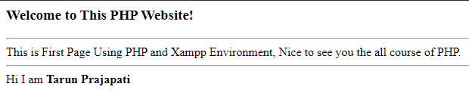

**1.2:**

<?php

$name = "Tarun Prajapati";//global variable

//local Variable

function local()

{

echo "<h3>Local Variable</h3>";

$sub = "PHP";

echo "Value Of Local Variable = " . $sub;

}

//Global Variable

function globaltest()

{

echo "<h3>Global Variable</h3>";

global $name;

echo "My Name is ".$name;

}

//constant Variable

function constanttest()

{

echo "<h3>Constant Variable</h3>";

define("surname","Prajapati");

echo "Your Surname is ".surname;

}

//static variable

function statictest()

{

echo "<h3>Static Variable</h3>";

static $n1 = 3;

$n2 = 5;

$n1++;

$n2++;

echo "Static Variable Value = " .$n1;

echo "<br>Non-Static Variable Value = " .$n2;

}

globaltest();

local();

constanttest();

statictest();

statictest();

statictest();

?>

**Output:**

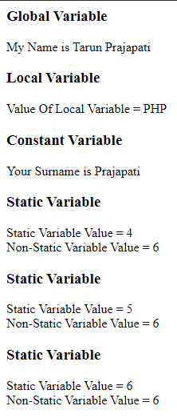

**Questions:**

1. Write down full form of WAMP, LAMP and XAMPP.
2. Justify: PHP is a Loosely Typed Language.

**1.3** Write a PHP script to demonstrate arithmetic operators, comparison operator, and logical operator

**Software Required:** Notepad, WordPad, Notepad++, Dreamweaver, Wamp/Xampp **Pre-requisite:** Basic knowledge of editor

**Theory/Logic:**

* Operators are used to perform operations on variables and values.
* PHP divides the operators in the following groups:

|  |  |
| --- | --- |
| * Arithmetic operators * Assignment operators * Comparison operators | * Increment/Decrement operators * Logical operators * String operators * Array operators |

# Arithmetic operator:-

**Comparison Operators:**

**-**

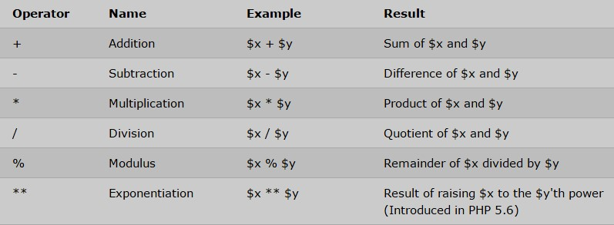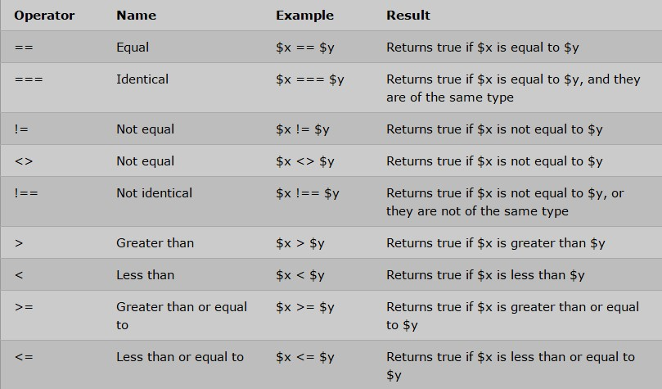

# Logical Operators:-

**Program/Solution:**

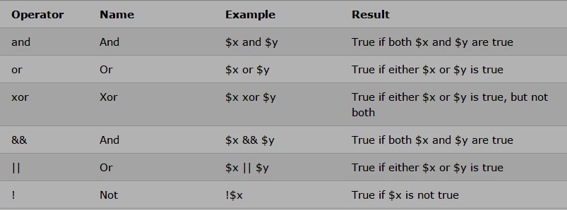

**1.3:**

<?php

$n1 = 10;

$n2 = 5;

$n3 = 10.0;

echo "<h2>Arithmetic Operators</h2>";

echo "Addition of $n1 and $n2 =" . $n1+$n2;

echo "<br>Subtraction of $n1 and $n2 =" . $n1-$n2;

echo "<br>Multiplication of $n1 and $n2 =" . $n1*$n2;

echo "<br>Divison of $n1 and $n2 =" . $n1/$n2;

echo "<br>Modulo of $n1 and $n2 =" . $n1%$n2;

echo "<h2>Comparison Operators</h2>";

if($n1==$n2)

{

echo "$n1 == $n2 is True";

}

else echo "$n1 == $n2 is False";

if($n1===$n3)

{

echo "<br>$n1 === $n3 is True";

}

else echo "<br>$n1 === $n3 is False";

if($n1>$n2)

{

echo "<br>$n1 is Greater than $n2";

}

else echo "<br>$n1 is Smaller than $n2";

if($n1!==$n2)

{

echo "<br>$n1 and $n2 is not identical";

}

else echo "<br>$n1 is $n2 identical";

echo "<h2>Logical Operators</h2>";

if($n1==10 and $n2==5)

{

echo "AND Opreator = Welcome!<b> Both Conditions are Satisfied</b>";

}

else echo " AND Opreator = Sorry!<b> Both Conditions are Not Satisfied</b>";

if($n1==10 or $n2==10)

{

echo "<br> OR Opreator = Welcome!<b> One Condition is Satisfied</b>";

}

else echo "<br> OR Opreator = Sorry!<b> No Conditions are Not Satisfied</b>";

?>

**Output:**

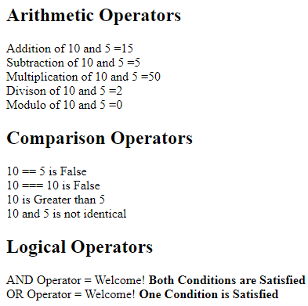

**Questions:**

1. List out logical operators in PHP.
2. List out Arithmetic operators in PHP.

* 1. Write PHP Script to print Fibonacci series.
  2. Write a PHP script to find a factorial of n using Recursive Function.
  3. Write a PHP script to Fibonacci series in html tabular format.
  4. Write PHP Script to generate result and display grade.
  5. Write a PHP Script to show different looping structure.

**Software Required:** Notepad, WordPad, Notepad++, Dreamweaver, Wamp/Xampp

**Pre-requisite:** Basic knowledge of editor

**Theory/Logic:** In PHP we have the following conditional statements:

#  PHP Conditional structure: -

* **if statement** - executes some code if one condition is true
* **if...else statement** - executes some code if a condition is true and another code if that condition is false
* **if...else if....else statement** - executes different codes for more than two conditions  **Switch statement** - selects one of many blocks of code to be executed.
* **syntax:**

Switch (n) { case label1:

code to be executed if n=label1; break; case label2:

code to be executed if n=label2; break; default:

code to be executed if n is different from all labels;

}

#  PHP looping structure:-

* It allows you to execute certain portion of the script repeatedly based on some condition.
* **for** - loops through a block of code a specified number of times

Syntax:-

◻ **for (*init counter; test counter; increment counter*) {  *code to be executed;***

**}**

• **foreach** - loops through a block of code for each element in an array.

Syntax:-

◻ **foreach ($array as $value)**

**{**

**code to be executed;**

**}**

• **while** - loops through a block of code as long as the specified condition is true

Syntax:

◻ **while (condition is true)**

**{**

**code to be executed;**

**}**

• **do...while** - loops through a block of code once, and then repeats the loop as long as the specified condition is true.

Syntax:

◻ **do { code to be executed;**

**} while (*condition is true*);**

**Program/Solution:**

**1.4:**

<?php

$st = 0;

$n1 = 0;

$n2 = 1;

echo "<h3>Fibonacci Series of First 10 Numbers</h3>";

echo $n1." ".$n2." ";

while($st<8)

{

$sum = $n2 + $n1;

echo "$sum ";

$n1 = $n2;

$n2 = $sum;

$st++;

}

?>

**Output:**

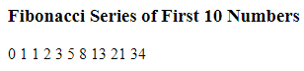

**1.5:**

<?php

function fact($n)

{

if($n <= 1)

{

return 1;

}

else

{

return $n * fact($n-1);

}

}

$n=5;

echo "<h3>Factorial</h3>";

echo "Factorial of $n is ".fact($n);

?>

**Output:**

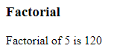

**1.6:**

<html>

<head>

<title>Document</title>

</head>

<body>

<h3>Fibonacci Series of First 10 Numbers</h3>

<table border="1px">

<?php

$st = 0;

$n1 = 0;

$n2 = 1;

echo "<tr><td>".$n1."</td></tr><tr><td>".$n2."</td></tr>";

while($st<8)

{

$sum = $n2 + $n1;

echo "<tr><td>$sum </td></tr>";

$n1 = $n2;

$n2 = $sum;

$st++;

}

?>

</table>

</body>

</html>

**Output:**

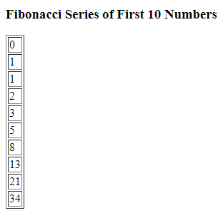

**1.7:**

<html>

<head>

<title>Gradesheet</title>

</head>

<body align="center">

<form method="post">

<table border=2 align="center" cellpadding="8" style="color: aqua" ; bgcolor=black>

<tr align="center">

<td>

Enrollment No :

</td>

<td>

<input type=text name="t1">

</td>

</tr>

<tr align="center">

<td>

Web and Network Security :

</td>

<td>

<input type=text name="t2">

</td>

</tr>

<tr align="center">

<td>

Advanced Java Programming :

</td>

<td>

<input type=text name="t3">

</td>

</tr>

<tr align="center">

<td>

Android Application Development :

</td>

<td>

<input type=text name="t4">

</td>

</tr>

<tr align="center">

<td>

Web Designing using PHP & MySQL :

</td>

<td>

<input type=text name="t5">

</td>

</tr>

<tr align="center">

<td>

Project - II :

</td>

<td>

<input type=text name="t6">

</td>

</tr>

<tr align="center">

<td colspan=2>

<input type=submit name="s" value="Result">

</td>

</tr>

</table>

<br>

<br>

<?php

$ER = $_POST['t1'];

echo "<h2 align=center><u>GTU Diploma SEM-6 Gradesheet</u></h2>

<h3 align=center>Enrollment No.:- $ER</h3>";

if (isset($_POST['s'])) {

$WNS = $_POST['t2'];

$AJ = $_POST['t3'];

$AAD = $_POST['t4'];

$PHP = $_POST['t5'];

$PRJ = $_POST['t6'];

$sum = ($WNS+$AJ+$AAD+$PHP+$PRJ)/5;

function grade($avg)

{

if ($avg >= 90 && $avg < 100)

echo "AA";

elseif ($avg >= 80)

echo "AB";

elseif ($avg >= 70)

echo "BB";

elseif ($avg >= 60)

echo "BC";

elseif ($avg >= 50)

echo "CC";

elseif ($avg >= 40)

echo "FF";

else echo "Sorry!";

}

}

?>

<table align="center" border="1" cellpadding="8" style="color: aqua" ; bgcolor=black>

<tr>

<th bgcolor="yellow" style="color: red;">Subject Code</th>

<th bgcolor="yellow" style="color: red;">Subject</th>

<th bgcolor="yellow" style="color: red;">Grade</th>

</tr>

<tr>

<tr>

<td>3361601</td>

<td>Web and Network Security</td>

<td><?php grade($WNS); ?></td>

</tr>

<tr>

<td>3360701</td>

<td>Advanced Java Programming</td>

<td><?php grade($AJ); ?></td>

</tr>

<tr>

<td>3361602</td>

<td>Android Application Development</td>

<td><?php grade($AAD); ?></td>

</tr>

<tr>

<td>3361603</td>

<td>Web Designing using PHP & MySQL</td>

<td><?php grade($PHP); ?></td>

</tr>

<tr>

<td>3361606</td>

<td>Project - II</td>

<td><?php grade($PRJ); ?></td>

</tr>

</table>

<p style=color:darkblue;> <b>Your Obtained Grade : <?php grade($sum)?></b></p>

<p style=color:darkblue;> <b>Average : <?php echo $sum ?></b></p>

<p style=color:red> <b>This is Your Result, Thank You.</b></p>

</body>

</html>

**Output:**

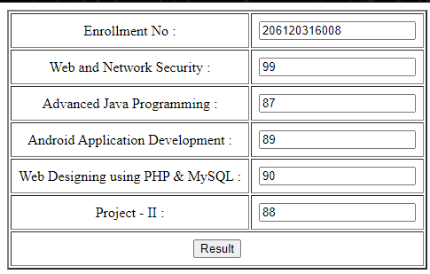

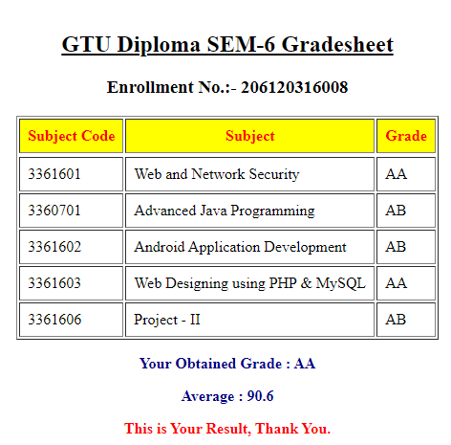

**1.8:**

<?php

$x = 1;

echo "<h2>While loop</h2>";

while($x<=3)

{

echo "<h5>Value of X = $x <br></h5>";

$x++;

}

$y = 1;

echo "<h2>do-while Loop</h2>";

do{

echo "<h5>Value of Y = $y <br></h5>";

$y++;

}while($y>=3);

echo "<h2>for Loop</h2>";

for($z=0; $z<=3; $z++)

{

echo "<h5>Value of Z = $z <br></h5>";

}

echo "<h2>foreach Loop</h2>";

$frd = array("Tarun","Sanket","Hansil","Pranav","Vaibhav","Milan");

foreach($frd as $value)

{

echo "<h5>Value = $value <br></h5>";

}

?>

**Output:**

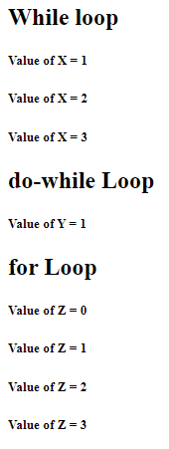 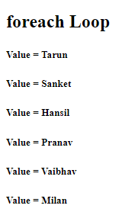

**Questions:**

1. Differentiate for V/S foreach loop.
2. In which situation foreach loop is used in PHP?

* 1. Write PHP Script to find maximum number out of three given numbers with and without Command line.
  2. Write a PHP script to call by reference and call by value.
  3. Write PHP script to display table of number 11.

**Software Required:** Notepad, WordPad, Notepad++, Dreamweaver, Wamp/Xampp **Pre-requisite:** Basic knowledge of editor

**Theory/Logic:**

**Steps for run PHP scripts in command line:**

1. Start a command prompt (Start button > Run > cmd.exe)
2. In the window that appears, type the full path to the PHP executable (php.exe) followed by the full path to the script you wish to run as a windows service. ...
3. Hit the Enter key to execute the command line.

**Call by Value:-**

* When you define a function that accepts arguments you must have to pass those arguments while calling function.
* If you pass wrong number of arguments at the time of calling the function then it will generate a warning message.
* In PHP you can define function having default argument.
* If you don’t pass value for that argument then it will consider default value for that argument otherwise it will overwrite value for argument.
* You need to assign the value to argument while defining the function.

**Call by Reference:**

* In this case, the address of the variable is passed into the function. Change to the value within the function will be reflected in the variable.
* To pass parameters into functions by reference, append & sign to the variable.

**Program/Solution:**

**1.9:**

<?php

echo "<h2>Maximum Number without Command Line</h2>";

$a = 10;

$b = 20;

$c = 30;

if($a>$b && $a>$c)

{

echo "Maximum Number = $a";

}

elseif($b>$a && $b>$c)

{

echo "Maximum Number = $b";

}

else echo "Maximum Number = $c";

echo "<h2>Maximum Number using Command Line</h2>";

echo "Enter Three Numbers<hr>";

echo "Enter First Numbers:";

$x = fgets(STDIN);

echo "Enter Second Numbers:";

$y = fgets(STDIN);

echo "Enter Third Numbers:";

$z = fgets(STDIN);

if($x>$y && $x>$z)

{

echo "Maximum Number = $x";

}

elseif($y>$x && $y>$z)

{

echo "Maximum Number = $y";

}

else echo "Maximum Number = $z";

?>

**Output:**

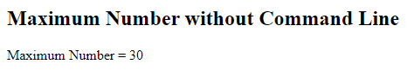

**Maximum Number with Command Line ::**

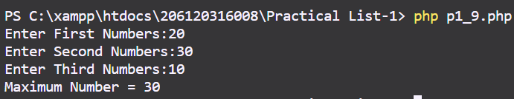

**1.10:**

<?php

function Pass_ByReference($x,&$y)

{

$x *= 2;

$y *=2;

}

$a=3;

$b=5;

echo "<h2>Before Function Call</h2>";

echo "Value of A = $a";

echo "<br>Value of B = $b";

Pass_ByReference($a,$b);

echo "<h2>After Function Call</h2>";

echo "Value of A = $a"; echo "<br>Value of B = $b"; ?>

**Output:**

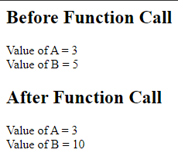

**1.11:**

<?php

echo "<h2>Table Of 11</h2>";

$n=11;

for($i=0; $i<=10; $i++){

echo "$i X $n = ".$i * $n;

echo "<hr>";

}

?>

**Output:**

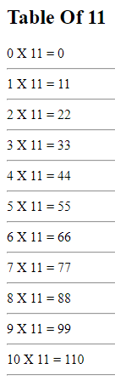

**Questions:**

1. Differentiate call by value Vs call by reference

**Aim:**

* 1. Write PHP Script for addition and multiplication of two 2x2 matrices.
  2. Write a PHP Script for numeric, Associative and multi-dimensional array.
  3. Write a PHP script to Find Perimeter and area of rectangle using parameterized function.
  4. Write a PHP Script for performing function that takes arguments, returns arguments, default argument and variable length argument.
  5. Write a PHP script to find var args that uses to find max and minimum of Passed parameters

**Software Required:** Notepad, WordPad, Notepad++, Dreamweaver, Wamp/Xampp

**Pre-requisite:** Basic knowledge of editor

**Theory/Logic:**

* There are mainly two types of arrays:-

1) Indexed/Numeric array. 2) Associative array. **Indexed/Numeric Array:-**

* These arrays can store numbers, strings and any object but their index will be represented by numbers. By default array index starts from 0;  An array is created using array() keyword. Syntax:-

**$ArrayName=array (value1, value2...ValueN);**

**Associative Array:-**

* In Associative array each element having key associated with it.
* The key can be either numeric or string. Syntax:-

**$ArrayName=array (key1=>value1, key2=>value2...keyN=>valueN);**

# User defined functions:-

* A function is a block of statements that can be used repeatedly in a program.
* There is no need to declare function in PHP. You can directly define function.

Syntax:-

Function *FunctionName* (arguments)

{ *//code to be executed*;

}

# Function with variable length argument:-

* PHP allows you to pass variable number of arguments to the function without defining it.
* You can just define a function with empty argument list and then use one of the following three built in function.
* **func_num_args ()** — Returns the number of arguments passed to the function.
* **func_get_args (position)** — Return the value of the specific argument specified in position. Position index starts with 0.
* **func_get_args ()** - Returns an array which contains value of all arguments passed to the function.

**Program/Solution:**

**1.12:**

<?php

$a = array(array(1,2),array(3,4));

$b = array(array(5,6),array(7,8));

echo "<h1>Matrix-1</h1>";

for($i=0;$i<2;$i++) {

for($j=0;$j<2;$j++){

echo $a[$i][$j]. " ";

}

echo "<br>";

}

echo "<h1>Matrix-2</h1>";

for($i=0;$i<2;$i++){

for($j=0;$j<2;$j++) {

echo $b[$i][$j]. " ";

}

echo "<br>";

}

echo "<h1>Matrix Addition</h1>";

for($i=0;$i<2;$i++){

for($j=0;$j<2;$j++) {

echo $a[$i][$j] + $b[$i][$j]." ";

}

echo "<br>";

}

echo "<h1>Matrix Multiplication</h1>";

for($i=0;$i<2;$i++) {

for($j=0;$j<2;$j++) {

$temp=0;

for($k=0;$k<2;$k++)

{

$temp += $a[$i][$k] * $b[$k][$j];

}

$m[$i][$j] = $temp;

echo $m[$i][$j] . " ";

}

echo "<br>";

}

**Output:**

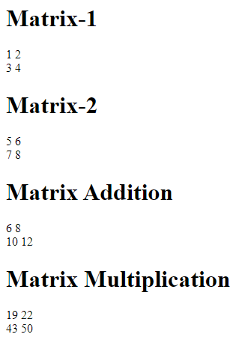

**1.13:**

<?php

echo "<h2>Indexed/Numeric Array</h2>";

$arr = array("India","USA","Russia","UAE");

echo "Countries = ". $arr[0]." ".$arr[1]." ".$arr[2];

echo "<hr>";

echo "<h2>Associative Array</h2>";

$arr1 = array("India"=>"Rupee","USA"=>"Dollar","Russia"=>"Russian Ruble","Iran"=>"Riyal");

print_r($arr1);

echo "<hr>";

echo "<h2>Multi-dimensional Array</h2>";

$arr2 = array(array(1,2,3),

array(4,5,6),

array(7,8,9));

echo "</h3>Matrix :</h3><br>";

for($i=0;$i<3;$i++){

for($j=0;$j<3;$j++) {

echo $arr2[$i][$j]. " ";

}

echo "<br>";

}

?>

**Output:**

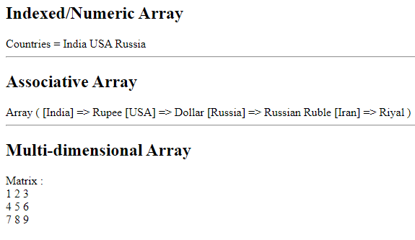

**1.14:**

<?php

echo "<h2>Perimeter Of Rectangle</h2>";

function getperimeter($l,$w){

$pm = 2 * ($l + $w);

echo "<h4>Perimeter of Rectangle = $pm</h4>";

}

function area($l,$w){

$ar = $l * $w;

echo "<h4>Area of Rectangle = $ar</h4>";

}

getperimeter(10,20);

echo "<h2>Area Of Rectangle</h2>";

area(10,20);

?>

**Output:**

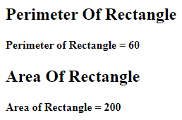

**1.15:**

<?php

function demo($a,$b=5) {

echo"<h2>Function with Argument,Return Arguments,Default Arguments,Variable Length Argument</h2>";

echo "No of Arguments = ". func_num_args();

echo "<br>";

echo "Arguments = ";

print_r(func_get_args());

return $a+$b;

}

echo "<br>Sum = ". demo(10);

?>

**Output:**

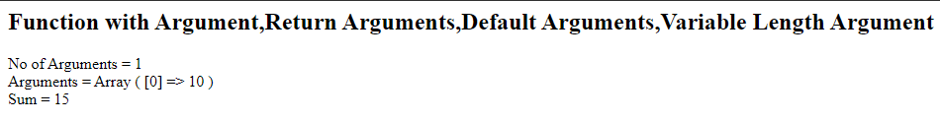

**1.16:**

<?php

function Max_Min(){

$arr = func_get_args();

echo "<b>Values = </b>";

$n = count($arr);

for($i=0;$i<$n;$i++) {

echo $arr[$i]." ";

}

sort($arr);

echo "<h4>Minimum Value = $arr[0]</h4>";

$x = $n-1;

echo "<h4>Maximum Value = $arr[$x]</h4>";

}

Max_Min(9,980,87,-7,9000,200,800,700,3000,609);

?>

**Output:**

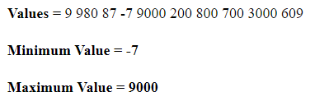

**Questions:**

* 1. In which situation associative array is used in PHP?
  2. Describe user defined function with default argument.

**Conclusion: -**